5731095821 Wasuwat Satittamajitrra

2110430 - Time Series Mining and Knowledge Discovery

Midterm Project: Jazz Standards to Time Series Data

**Introduction**

In this project, I transform chord progressions from jazz lead sheets into time series data. It is reasonable to assume that similar chord progressions will produce similar time series data. In jazz music, I can think of two popular chord progressions, which are “blues” and “rhythm changes”. Therefore, the transformed data of those two progressions should be distinguishable.

**The procedures**

The data are from an app called ‘iReal pro’. In the app, I can export chord progressions from jazz tunes into XML files. After that, I can process the files; get the structure of the songs (e.g. repeat symbol, different endings, etc.) and remember the chord alphabets and chord types to be processed later. About the chords, there is a special case needed to be handled which is the “half-diminished (minor seventh flat five)” chords. In the XML files, they are treated as “minor seventh, altered, the fifth is flatted” chords, I have to rename them to “half-diminished” chords, because I should not treat them as minor seventh chords and this chord type appears a lot in jazz music. I disregarded the other alterations and tensions (#9, ♭9, etc.). Sometimes, chords are changed so often, maybe every beat in a bar, so I memorized the chords in all beats of the songs. In the end, for a jazz tune, we will have an array that stores the chords for all beats of the tune.

Let’s move on to the algorithms. I defined a transformation function to convert the chords in the array into integers. The function can be seen below.

F (x) = 30 * Y(x.chordType) + Z(x.chordAlphabet) ; x is a chord (e.g. “C major seventh” , “F minor seventh”, etc)

chordTypes are {major, minor, dominant seventh, half-diminished, diminished, augmented}

chordAlphabets are {A, B, C, D, E, F, G}, with or without # or ♭

Y(Major) = 0 ; Y(Minor) = -1 ; Y(Dominant) = +1 ; Y(Half-Diminished) = -2

Y(Augmented) = +2 ; Y(Diminished) = -3

About the function Z, I used cycle of fifths to calculate. A result is the number of accidentals appear in the major key signature, +1 per #, -1 per ♭. I treated enharmonic as different alphabets.

Examples

G minor seventh = 30 * Y(minor) + Z(G) = 30*(-1) + (+1) ; G major scale has 1#

= 30

C major seventh = 30 * Y(major) + Z(C) ; C major scale has no accidental

= 0

The function will map chords to integers; different chords (regardless of tensions) will be mapped to different integers.

I did this to every chord, so in the end I get an array of integers. Lastly, let’s see the results.

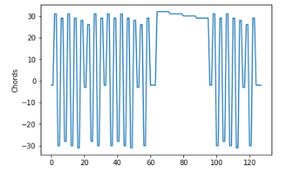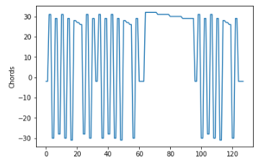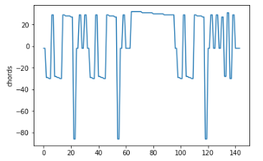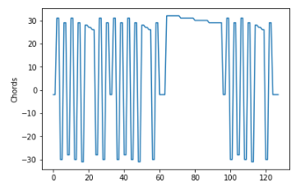

Fig .Rhytyhm Changes (from upper left to lower right) – Dexterity, The Theme, Anthropology, I got Rhythm. (All are in Bb)

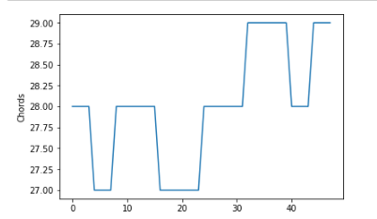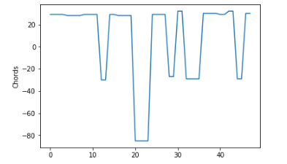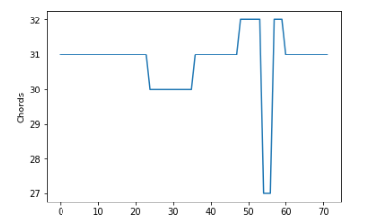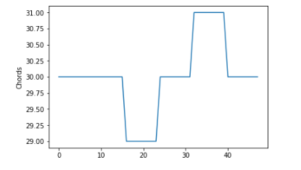

Fig .The Blues (from upper left to lower right) – Straight no Chaser (Bb), Au Privave (F), All Blues (G), C-Jam Blues (C)

As you can see, even the tunes are in different keys, the patterns produced by the function are still quite similar. (No need to find the key of the tune and transpose beforehand)

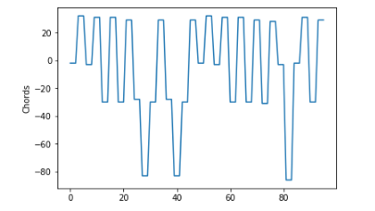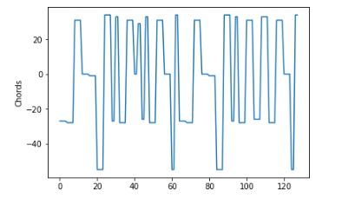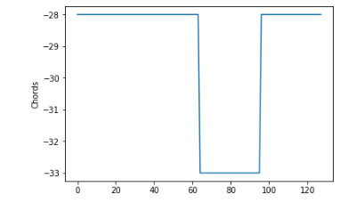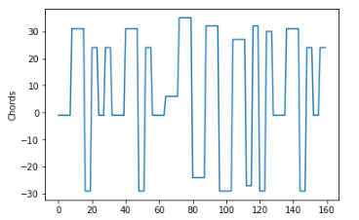

Fig .The other tunes (from upper left to lower right) – My favorite things, Fly me to the moon, So what, The girl from Ipanema

For more information, take a look at my github.

<https://github.com/Worse2Worst/TimeSeries-Midterm>